Sensor Fusion

* Phil’s Lab example
  + 3 Axis accelerometer and 3 Axis gyroscope.
  + Possibly applying a low-pass filter to the measurement.

**Accelerometer Equations:**

$$\left[\begin{matrix}a_{x} \\ a_{y} \\ a_{z}\end{matrix}\right]=\frac{dv}{dt}+w_{b}×v-R*\left[\begin{matrix}0 \\ 0 \\ g\end{matrix}\right]+β\left(t\right)+η\left(t\right)$$

* Where $β(t)$ is the bias of the accelerometer and $η(t)$ is the noise of the accelerometer.
* If we assume the body which the accelerometer is attached to is at rest:

$$\left[\begin{matrix}a_{x} \\ a_{y} \\ a_{z}\end{matrix}\right]=R*\left[\begin{matrix}0 \\ 0 \\ g\end{matrix}\right]=\left[\begin{matrix}g*sin⁡(θ) \\ -g*\cos\left(θ\right)*sin⁡(ϕ) \\ -g*\cos\left(θ\right)*cos⁡(ϕ)\end{matrix}\right]$$

$θ: Roll$

$ϕ: Pitch$

$γ: Yaw$

Through variable cancellation.

$${\hat{ϕ}}_{acc}=\tan^{-1}\left(\frac{a_{y}}{a_{z}}\right)$$

$${\hat{θ}}_{acc}=\sin^{-1}\left(\frac{a_{x}}{g}\right)$$

**Gyroscope Equations:**

Measure angular rate of rotation around body axes:

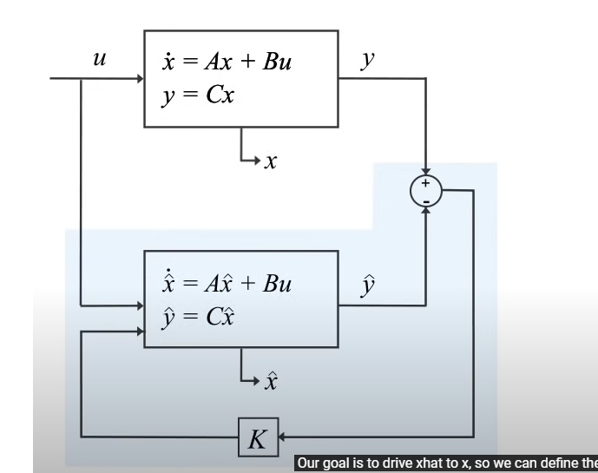

# Kalman Filter

**Kalman Filter** is a two step process, that starts from the prediction step.

$$x_{t+1}=Ax_{t}+u, u\sim N\left(0,P\right)$$

$$y_{t}=Hx_{t}+v, v\sim N(0,Q)$$

Surprise term is the difference between the measured velocity and the estimated velocity.

$$x=x_{0}+v_{0}∆t+\frac{1}{2}∆t^{2}$$

$$x_{n+1}=x_{n}+vdn$$

* Where $dn$ is the difference in time between two updates. ( $z_{n}$ is some measurement of $x_{n}$)
$$z_{n}=x_{n}+v$$

* **Time update:** based on the current state of the system, we predict its new state. In the case of a train, this means predicting its next position based on its previous position and previous velocity.
* **Measurement update:** the prediction generated in the step before is corrected using the data from a sensor.
* We can calculate the standard deviation of the sensor through experimentation.
  + I propose an experiment that we go from 0 degree to 90 degree and 90 degree to 180 degree and take the measurement from that.
 $$\hat{x_{1}}=\hat{x_{0}}\left(1-k_{1}\right)+z_{1}k_{1}$$

 + The above method is just linear interpolation, which is an interesting strategy.

**Sensor Fusion:**